COMMUNIQUE

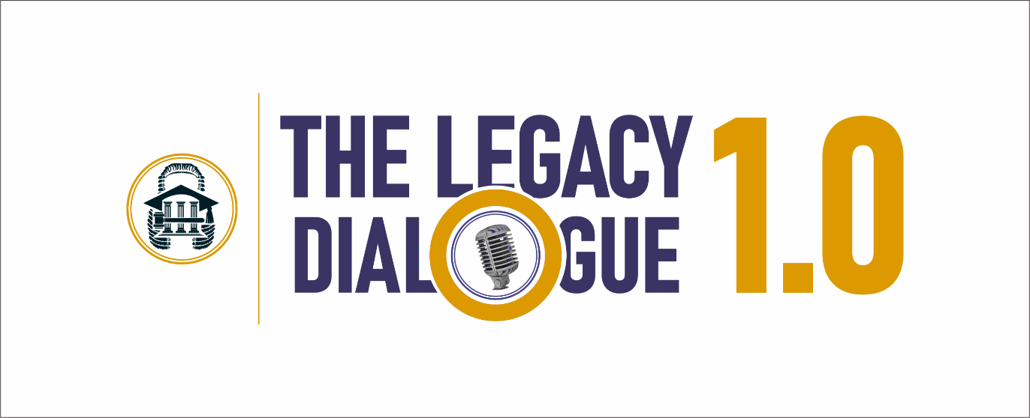

“THE FUTURE OF LAW & PROFESSIONAL IDENTITY FORMATION:
THE ROLE OF STRATEGIC SPONSORSHIP & MENTORSHIP”

JASAN FOUNDATION | #THELEGACYDIALOGUE

COMMUNIQUE ISSUED AT THE END OF THE LEGACY DIALOGUE ORGANISED BY THE JASAN FOUNDATION ON FRIDAY, 13TH SEPTEMBER 2024 AND HELD AT THE SHEHU MUSA YAR’ADUA CENTRE, ONE MEMORIAL WAY, CENTRAL BUSINESS DISTRICT [CBD], ABUJA, FCT – NIGERIA

- INTRODUCTION

The inaugural edition of The Legacy Dialogue 1.0, by the Johnny Agim, SAN Foundation [“JASAN Foundation”] with the theme “The Future of Law & Professional Identity Formation: The Role of Strategic Sponsorship & Mentorship”, was held on the 13th of September 2024 at the Shehu Musa Yar’Adua Centre, Abuja, Federal Capital Territory, Nigeria. The event brought together legal professionals, academics, and stakeholders to address key issues surrounding the development of the legal profession through mentorship and sponsorship.

- THE PANEL, PARTICIPANTS & THEMATICS

The event programme included, an Opening Address by Mr. Johnny Agim, SAN, the Founder/President of JASAN Foundation, a Keynote Speech by Prof. Ernest Ojukwu, SAN [Partner, OFY-Lawyers.Com] as well as a Panel Discussion which featured Hon. Justice Mabel T. Segun-Bello [Judge of Federal High Court], Prof. Isa Hayatu Chiroma, SAN [Director-General, Nigerian Law School] and Mr. Ayotunde F. Ogunleye, SAN [Founder / Principal Partner, Legal Tuxedo & Associates]. The Panel was adroitly moderated by Mr. Oyetola M. Atoyebi, SAN [Managing Partner, OMAPLEX Law Firm].

The thematics of the Dialogue included the following:
- The Judiciary, the Academia, & Legal Practice Business [LPB],
- The power of mentorship,
- The role of sponsorship, and
- The intersection of mentorship and sponsorship.

The Panel and participants underscored the rapid evolution within the legal profession, driven by technological advancements, globalisation, and evolving client needs. These shifts it noted demanded that legal professionals not only adapt to new tools and methodologies but also form strong professional identities that can thrive in an ever-changing environment; and this required critical mentorship. Participants also noted that currently, in the legal profession there is a significant lack of structured mentorship and applauded the JASAN Foundation for taking this giant step to provide an institutional and trans-generational platform for the legal profession.

The goal of The Legacy Dialogue 1.0, was to address the theme from the origin of the identity of the young lawyer, as well as the place of mentorship and sponsorship with respect to their aspiration, vision, pursuit of purpose, ultimate achievement in life and the role of the respective stakeholders, from three divergent yet contiguous perspectives, viz, the judiciary, legal practice, and the academia [educational development and training]. Therefore, the Panel drew on varied ideas, perspectives, and experiences in analysing the topic as it took a glimpse into the future of the Legal Profession in Nigeria strengthened by effective and impactful scholarship, sponsorship and mentorship for a mutually beneficial future – one that would “foster sustainable growth and development” for the system and its various stakeholders.

- OBSERVATIONS

#TheLegacyDialogue 1.0 observed as follows:

  - Scholarships and sponsorships are transformative catalysts in legal education, extending far beyond mere financial assistance. By democratising access to legal studies, these initiatives bridge the gap between talent and opportunity, fostering a diverse and inclusive legal profession that mirrors the society it serves. So, funding specialised legal studies, scholarships and research, propels the evolution of the law, fostering innovation and addressing emerging challenges.

  - Mentoring is very essential in the legal profession as the mentee is shown a clearer pathway towards fulfilling his ambition, such as the necessary pitfalls to avoid and invaluable advice given to him by his mentor who, by virtue of experience is better grounded and equipped than himself - in the knowledge, practice, art, and business of the law. This mentoring also helps to instill the much-needed values in the legal profession, thereby preserving the tradition of the legal profession.

- KEY RESOLUTIONS & RECOMMENDATIONS

In the light of the focus, thematics and the observations by #TheLegacyDialogue the following key recommendations and resolutions were made:

  - Commitment to Mentorship and Sponsorship: - The JASAN Foundation reaffirms its commitment to enhancing mentorship and sponsorship within the legal profession to foster professional identity formation, the study, development and application of the art and business of law [practice areas & sectors]; as well as the career development and excellence among young lawyers.

  - Establishment of Structured Programmes as a foundation for Professional Growth, Career Advancement and Legal Excellence: - There is an urgent need for the relevant stakeholders in the legal industry to create innovative mentorship and sponsorship programmes that adapt to the evolving legal landscape and leverage modern technologies. These programmes must be implemented across the legal industry [practice areas and sectors] - the Bar, Bench, and Academia, to equip young practitioners with requisite practical skills and ethical grounding.

  - Legal Service Reforms and Advocacy: - There is an urgent need for legal reforms that address the dearth of a systematic and structured pupillage and mentorship in the Nigerian legal profession – pre, during and post-law school to support new lawyers in navigating their careers effectively. The JASAN Foundation is committed to filling this gap by supporting indigent lawyers, fostering public interest advocacy as well as strategic collaborations.

  - Technology and Innovation in Mentorship and Sponsorship: - Mentorship and sponsorship programs must adapt to the changing legal landscape by leveraging modern technologies to create dynamic and continuous engagement between sponsors, mentors, and mentees.

  - Diversity, Inclusion & Safety: - Mentorship programmes must prioritise the safety and well-being of the participants as well as guaranteeing inclusivity by ensuring that individuals from diverse backgrounds are given equal opportunities to succeed in the legal profession. The Foundation commits to fostering a more inclusive and diverse legal ecosystem.

  - Emphasis on Continuous Legal Education: - Legal professionals especially young lawyers are encouraged to engage in ongoing continuing legal education to remain competitive and informed in their chosen practice areas.

- CONCLUSION

The Legacy Dialogue 1.0 highlighted the critical role of strategic sponsorship and mentorship in shaping a resilient and successful legal profession. By implementing these resolutions, we can ensure a robust future for young lawyers equipped with the necessary skills and insights to thrive in an ever-changing legal environment and becoming institutions of their own.

The JASAN Foundation commits to building a sustainable and institutionalised legal ecosystem to promote mentorship, sponsorship, and legal reforms, ensuring the development and excellence of a future-ready generation of legal professionals and to work with relevant stakeholders in this pursuit.

In view of the foregoing, JASAN Foundation therefore calls on the judiciary, the academia, legal professionals and all stakeholders in the legal profession, especially senior lawyers, as well as the legacy and established law firms to make a commitment to and collectively promote excellence through structured mentorship and sponsorship initiatives; while young lawyers are called upon to actively seek out mentors to guide their career development.

The Nigerian Bar Association (NBA) is also urged to take deliberate steps to collaborate with the JASAN Foundation and other stakeholders to promote and execute mentorship and sponsorship initiatives, including developing technology-based mentorship platforms for ongoing professional development to ensure holistic development for young lawyers, and drive positive change in the legal profession.

This is #TheLegacyDialogue 1.0

Thank you.

Mr. Johnny Agim, SAN Sen. Kanu G. Agabi, SAN, CON
PRESIDENT CHAIRMAN, BOARD OF TRUSTEES

CONTACT INFORMATION

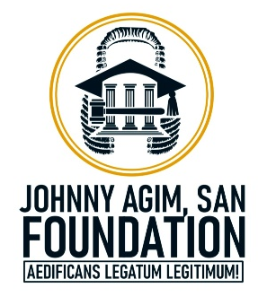

NO. 6, COTONOU STREET
[BLK 5B], WUSE ZONE 6
ABUJA, FCT – NIGERIA
T.: +234 [0] – 805 – 117 – 2811
E.: info@jasan-foundation.org | jasan.foundation@gmail.com
W.: www.jasan-foundation.org

